𝐃𝐞𝐯𝐞𝐥𝐨𝐩𝐞𝐫𝐬𝐇𝐮𝐛 𝐂𝐨𝐫𝐩𝐨𝐫𝐚𝐭𝐢𝐨𝐧 𝐢𝐧𝐭𝐞𝐫𝐧𝐬𝐡𝐢𝐩 𝐩𝐫𝐨𝐠𝐫𝐚𝐦
(Week 1)
DHC - 2384
Syed Muhammad Hamza Mehdi
2026
SECTION 1 — INTRODUCTION:
"This report documents the security assessment and hardening of OWASP
Juice Shop, a deliberately vulnerable web application designed to simulate
real-world security flaws. The application was assessed for common
vulnerabilities including Cross-Site Scripting (XSS), SQL Injection, and
weak authentication. Following the assessment, security fixes were
implemented and verified through re-testing."

Application Tested: OWASP Juice Shop
Version: Latest (2024/2025)
Testing Period: May 12–14, 2026
Environment:
- Windows 11 (Application Host — localhost:3000)
- Kali Linux via VMware (Attack Machine — OWASP ZAP)
- Node.js v24

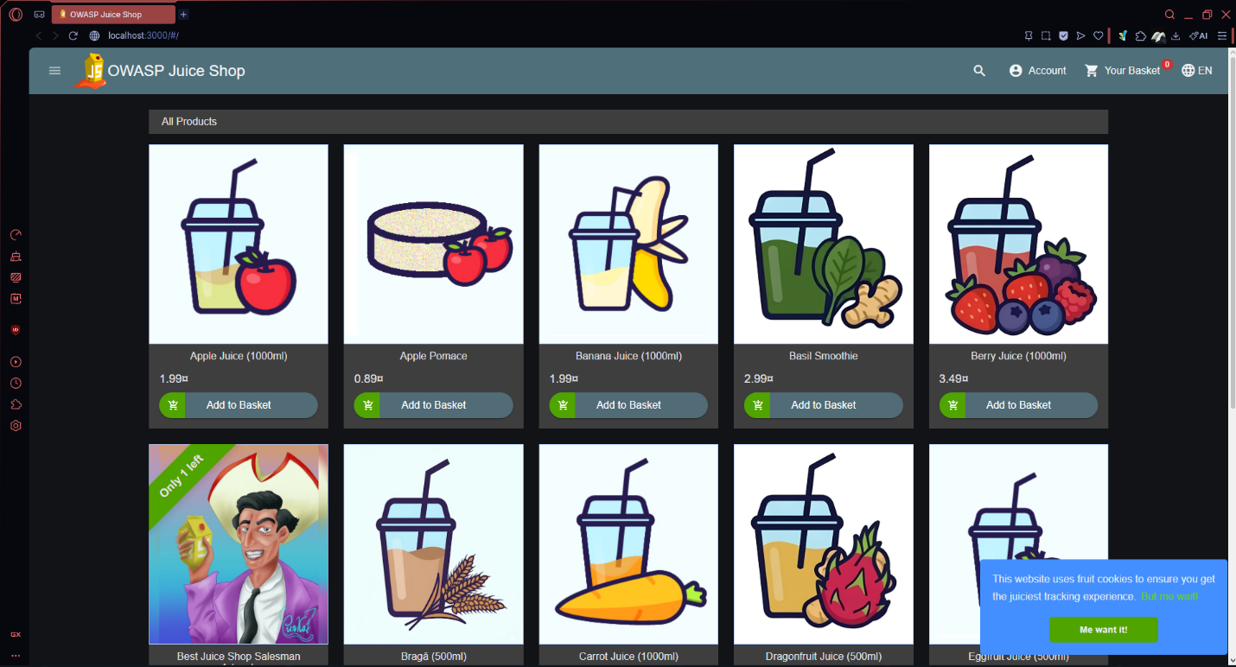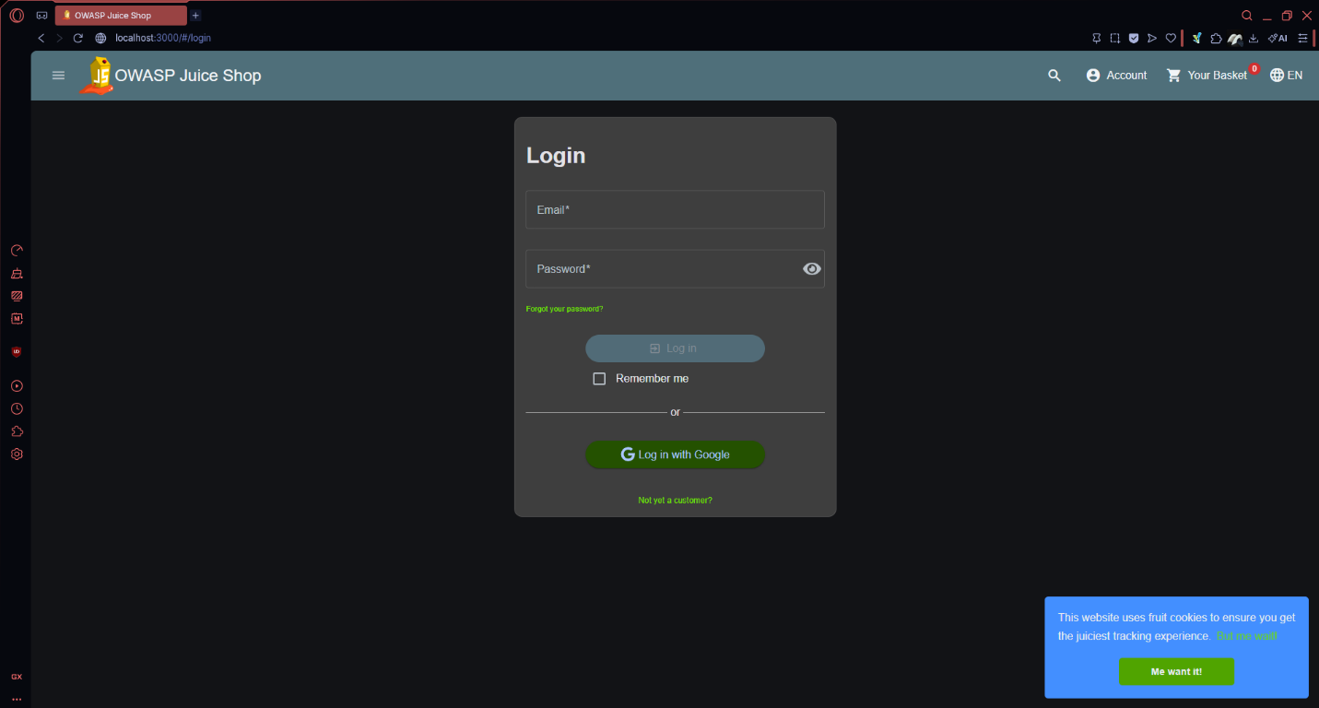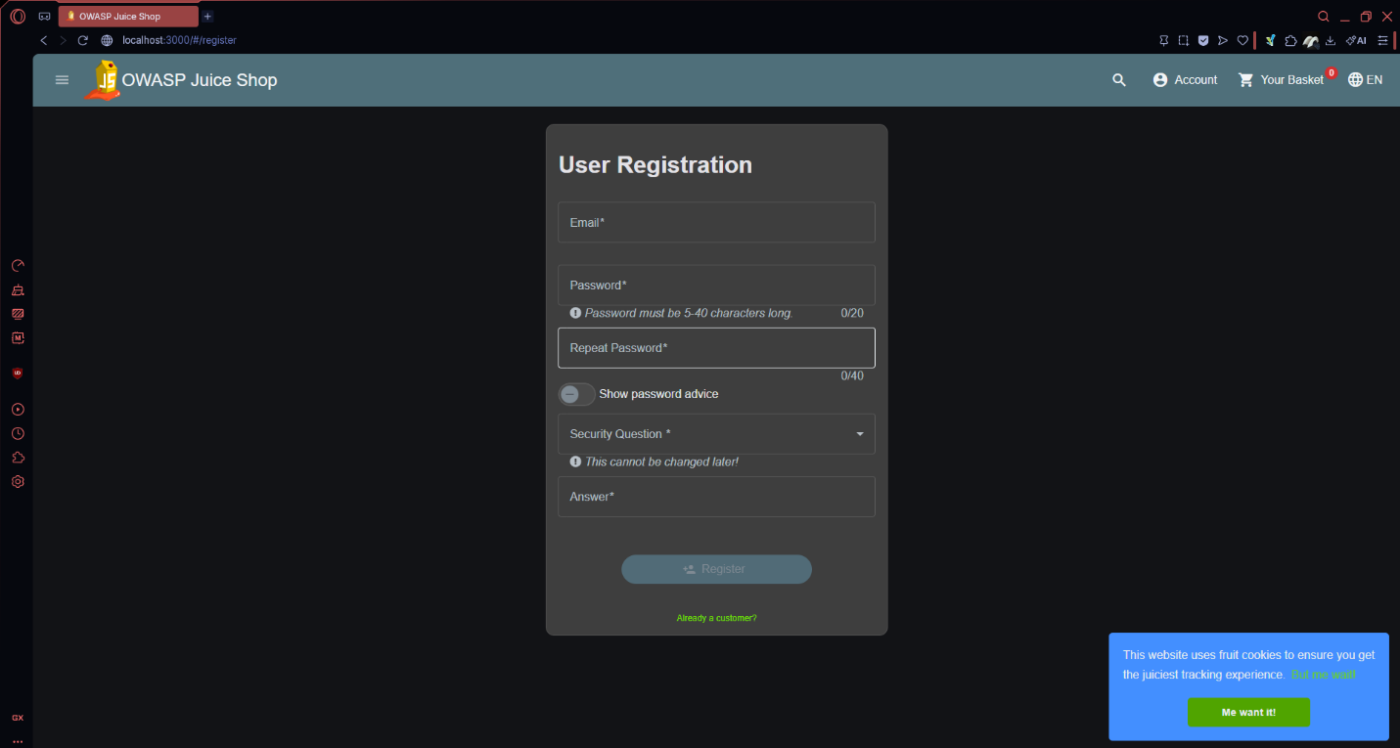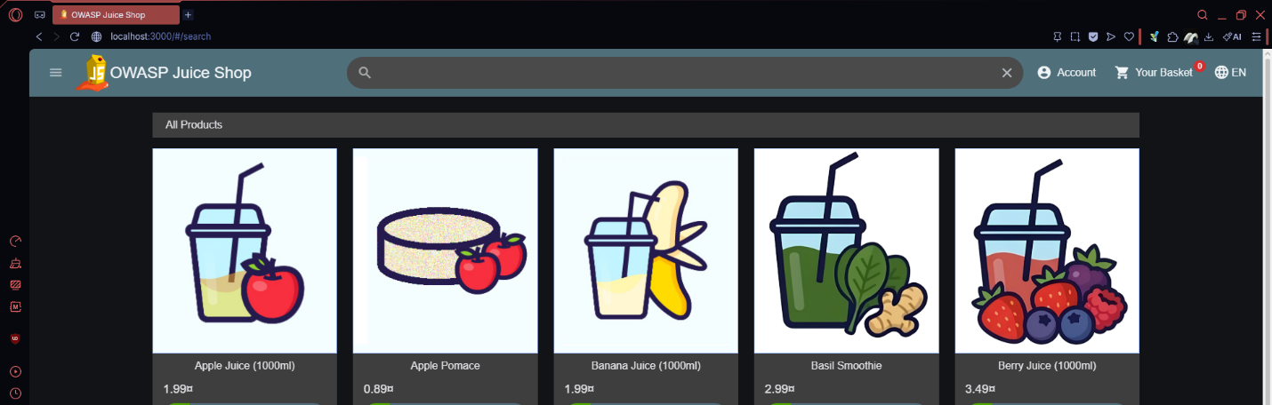

SECTION 2 — VULNERABILITY ASSESSMENT

2.1 Cross-Site Scripting (XSS)

Tool Used: Browser Developer Tools, Manual payload injection
Fields Tested: Search bar, Product review section, URL parameters

Test 1 — Search Bar:
Payload: <iframe src="javascript:alert('XSS')">
Result: An alert popped up as soon as I pressed enter
Severity: High

Test 2 — Product Review:
Payload: <script>alert('XSS in review')</script>
Result: Nothing showed up
Severity: High

Test 3 — DOM XSS via URL:
Payload: Injected via URL query parameter
Result: Could see it being blocked in Networks tab
Severity: Medium

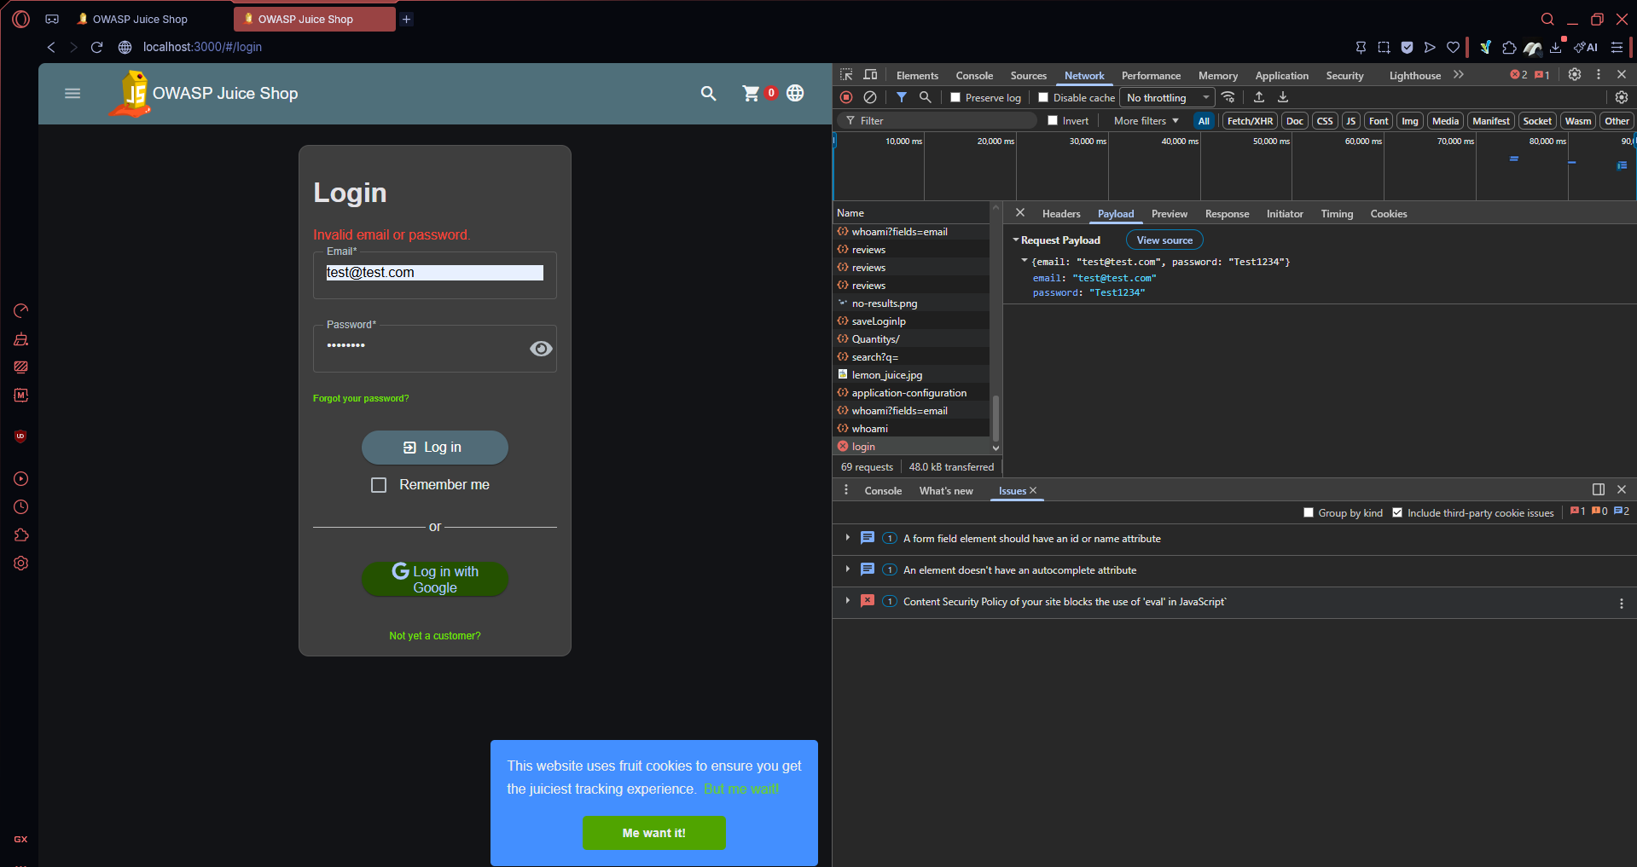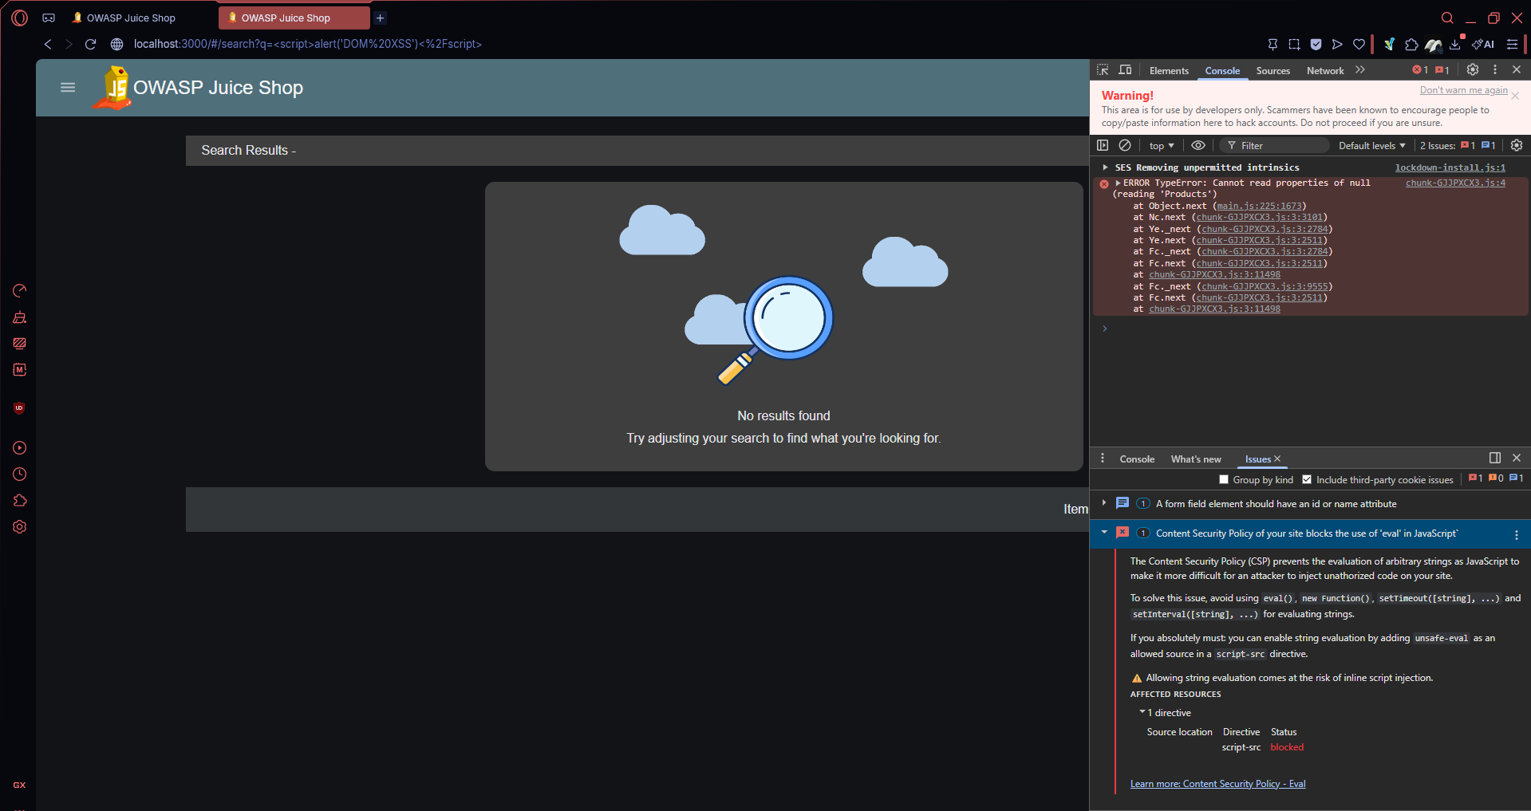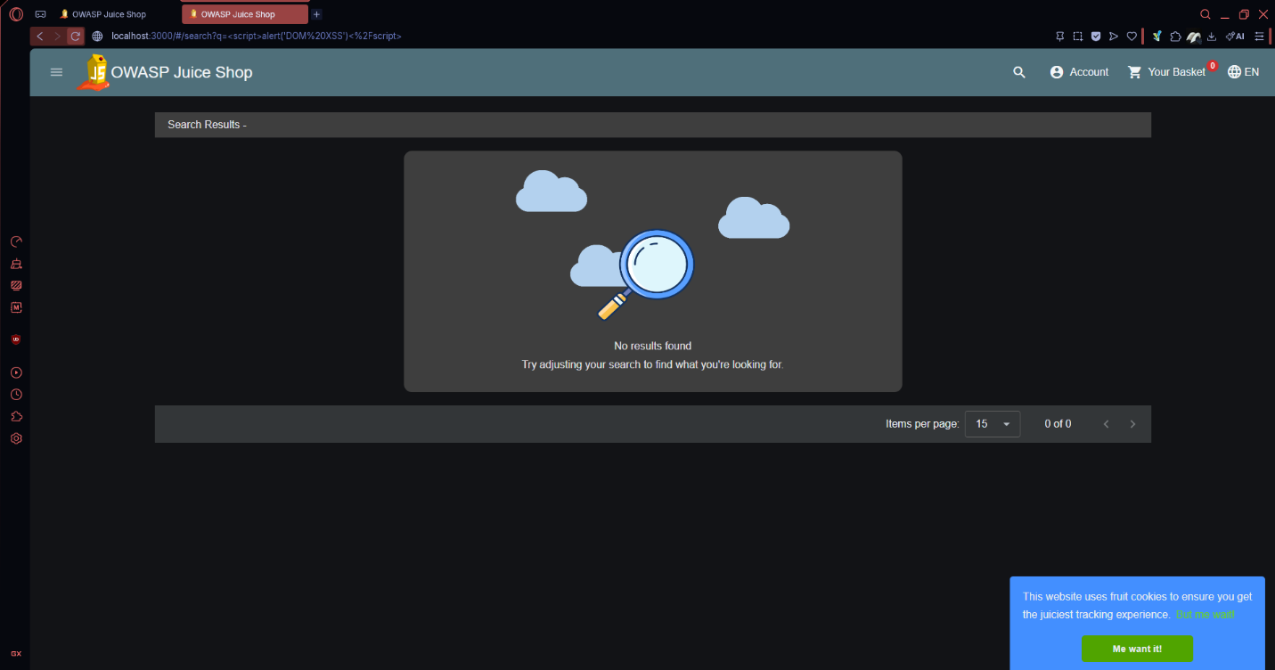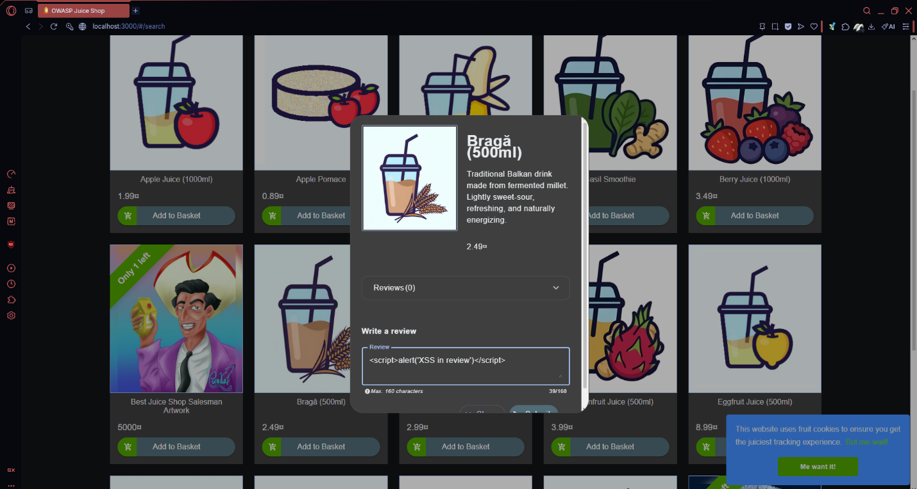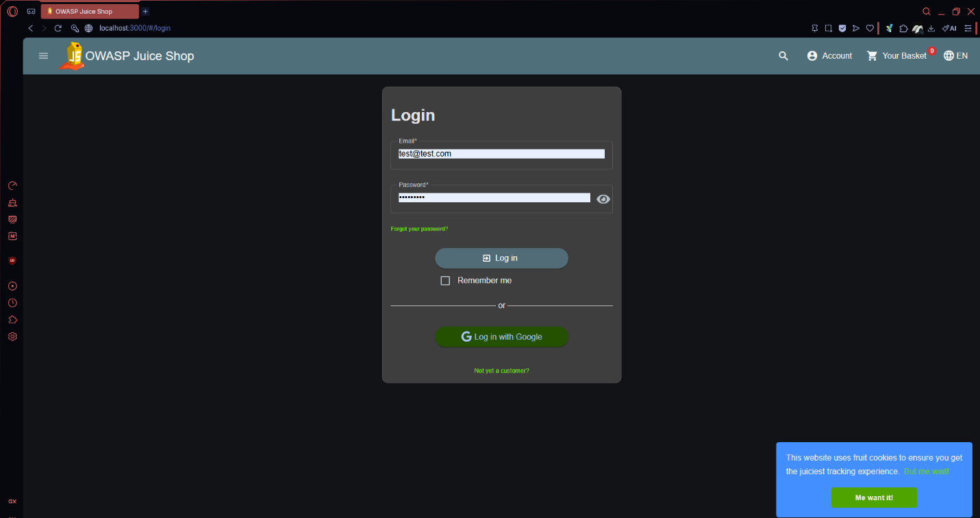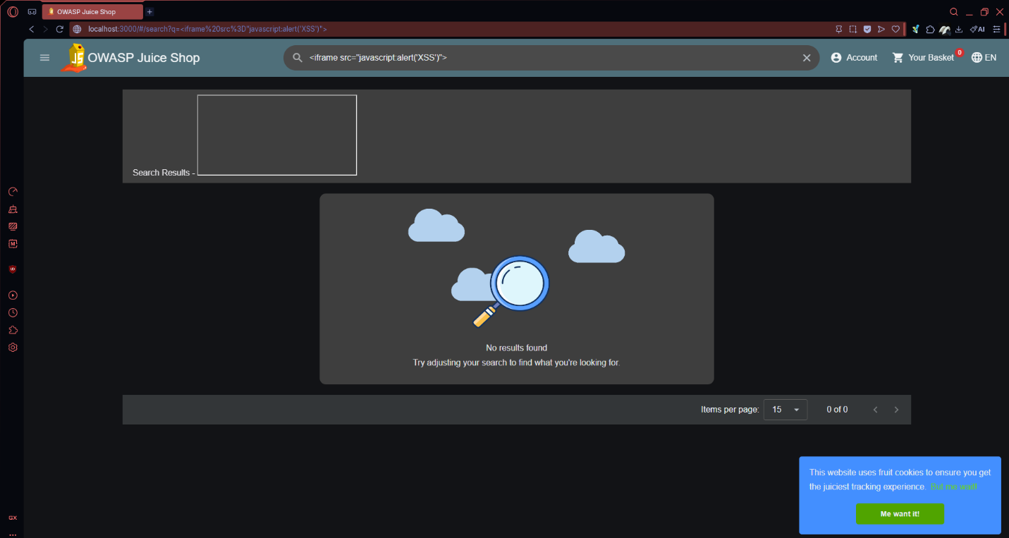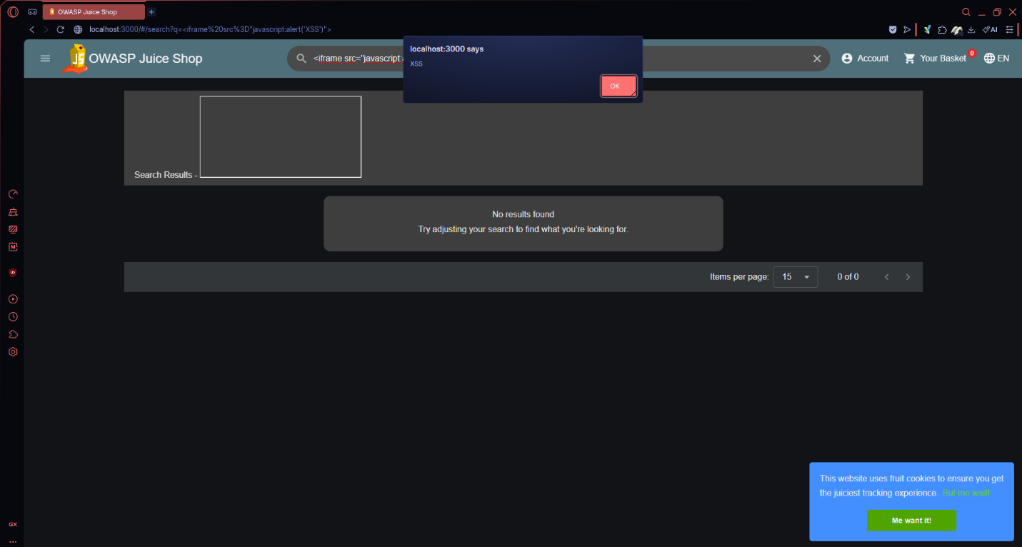
Impact: XSS vulnerabilities allow attackers to inject malicious scripts
into pages viewed by other users, potentially stealing session cookies,
redirecting users, or performing actions on their behalf.

2.2 SQL Injection

Tool Used: Manual testing on login form
Fields Tested: Email and password fields on login page

Test 1 — Login Bypass:
Payload: ' OR 1=1-- (email field)
Result: Successfully logged in as administrator without valid credentials
Severity: CRITICAL

Test 2 — Error-Based SQLi:
Payload: test@test.com' (single quote to trigger error)
Result: Only error in network response
Severity: High

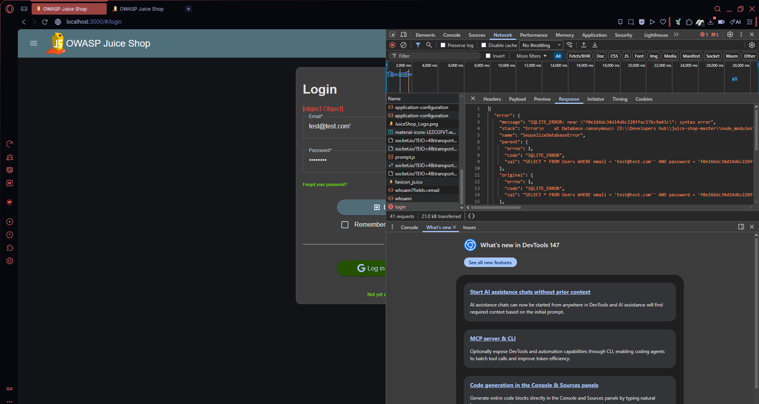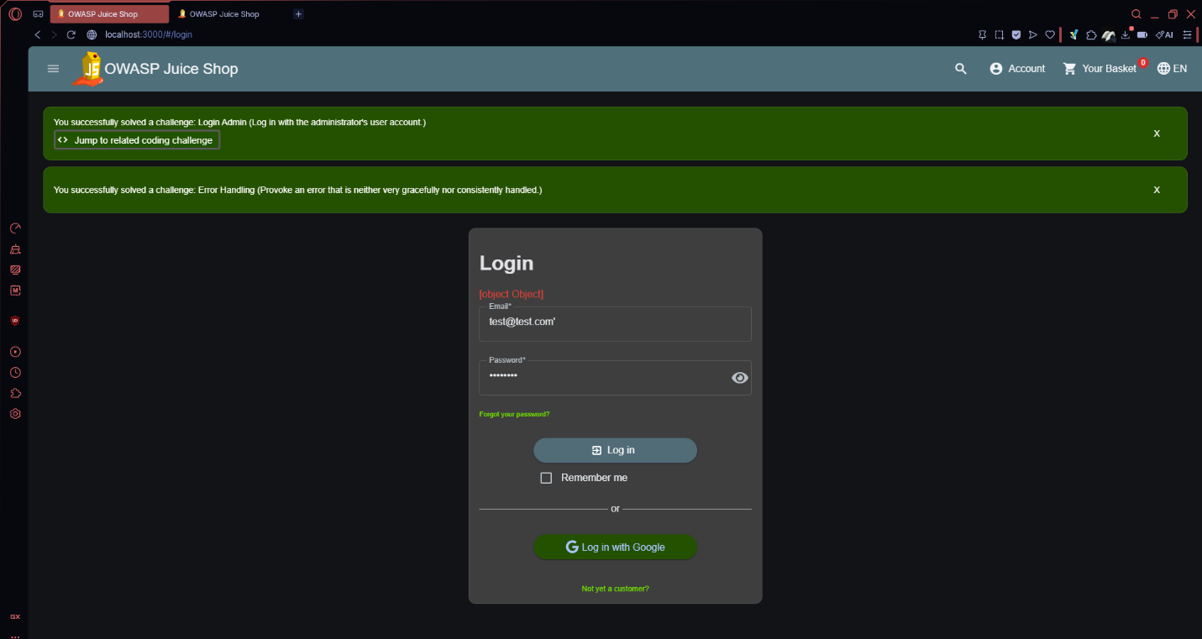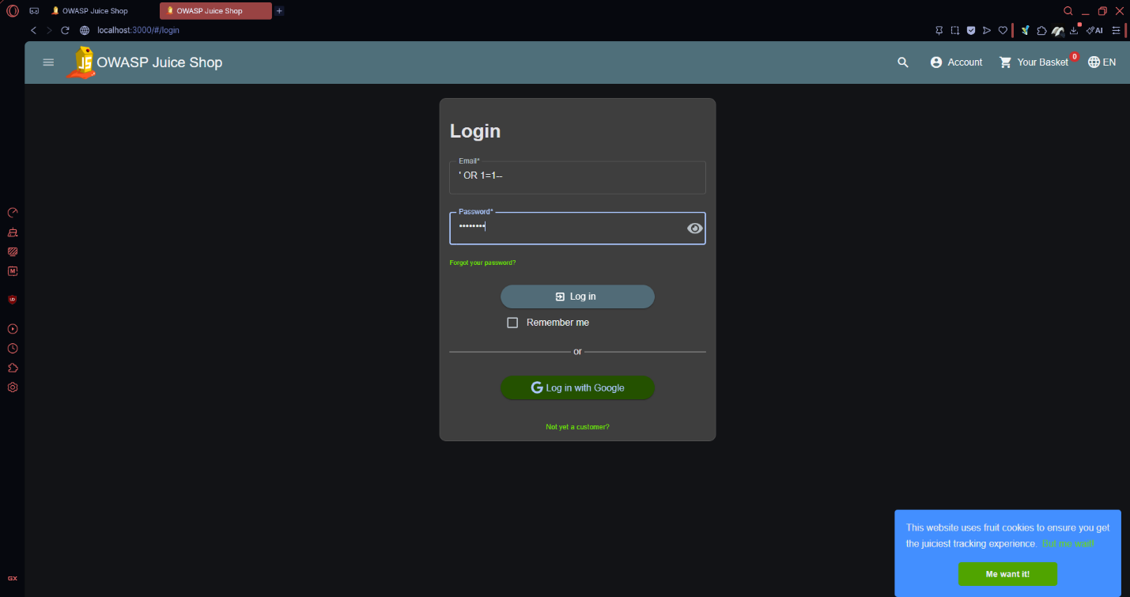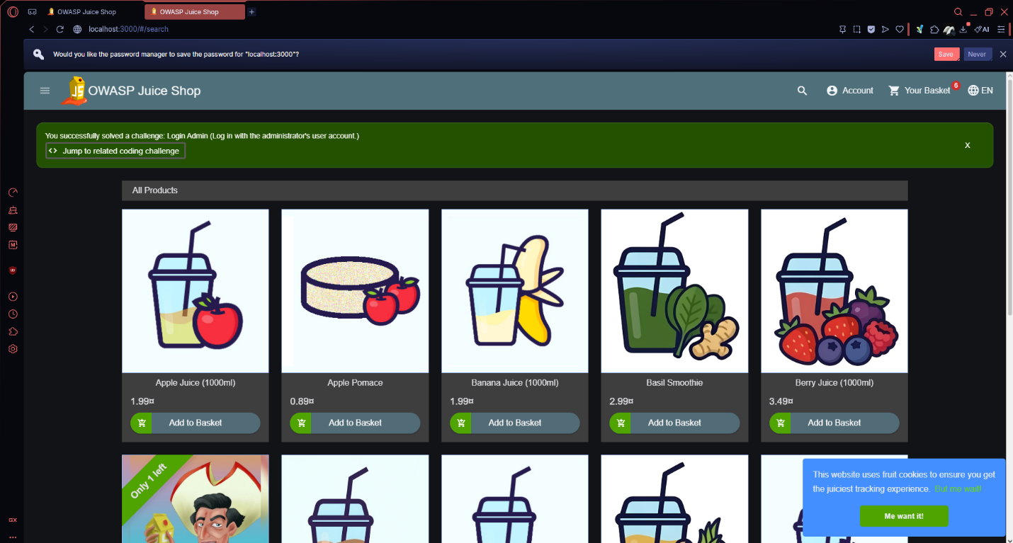
Impact: SQL Injection allows attackers to bypass authentication entirely,
access any user account, extract the full database, and potentially
delete or modify all application data.

2.3 Weak Password Storage

Method: Source code review
File Reviewed: models/user.ts

Finding: Passwords are stored using MD5/weak hashing without proper
salting, making them vulnerable to rainbow table attacks.
Severity: Critical

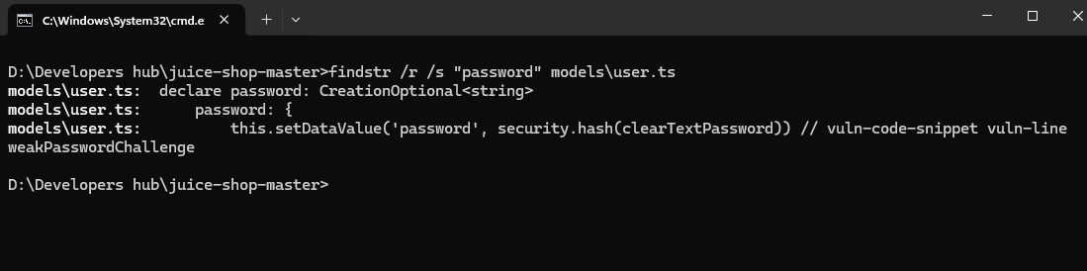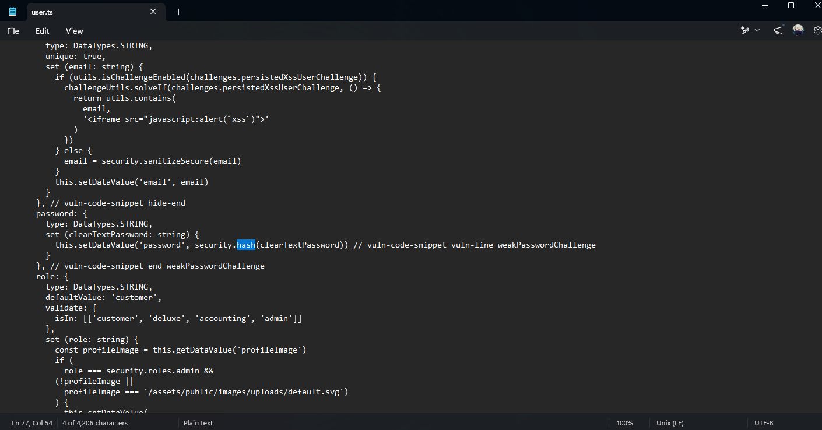
Impact: If the database is compromised, all user passwords can be
cracked quickly using precomputed hash tables.
2.4 Automated Vulnerability Scan — OWASP ZAP

Tool Used: OWASP ZAP (on Kali Linux)
Scan Type: Automated Active Scan
Target: http://192.168.166.1: 3000

Findings: FULL ZAP REPORT ATTACHED IN SUBMISSIONS
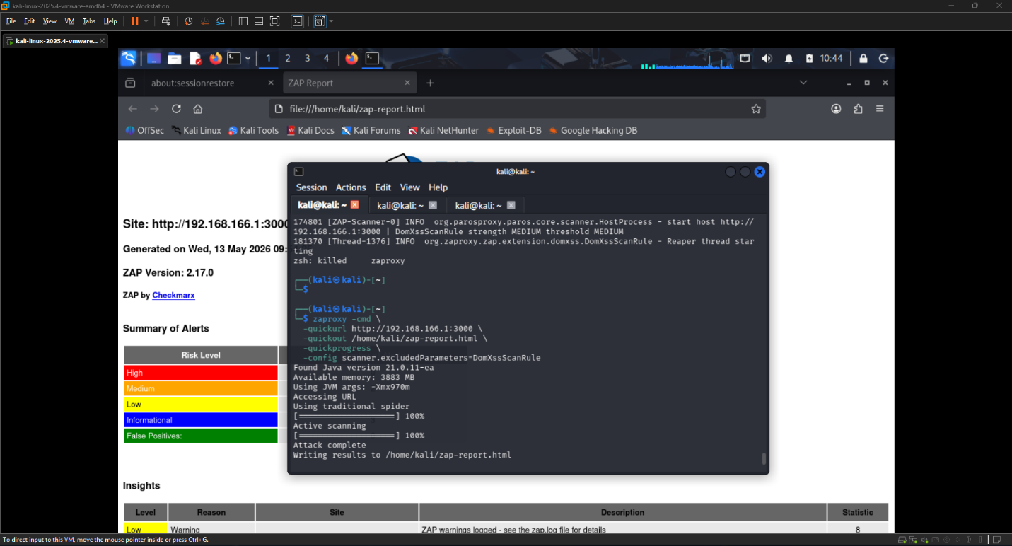

VULNERABILITY SUMMARY TABLE
# | Vulnerability | Severity | Method | Status
1 | DOM/Reflected XSS | High | Manual + ZAP | Open
2 | SQL Injection (Login) | Critical | Manual | Open
3 | Weak Password Hashing | Critical | Code Review | Open
4 | Missing Security Headers | Medium | ZAP Scan | Open
5 | Sensitive Data Exposure | HIgh | ZAP + Manual | Open

